ST. JOHNS COMMUNITY HEALTH - JANITORIAL SCOPE OF WORK

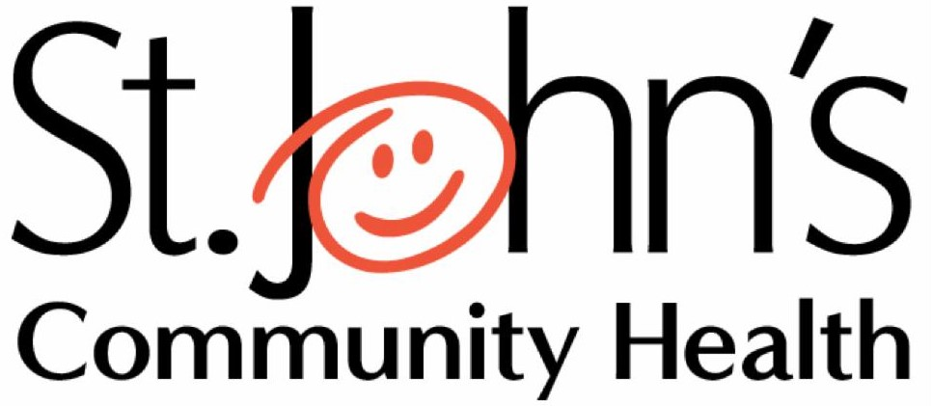

St. Johns Service Schedule –

Areas To Be Serviced– Exam Rooms, Offices, Common Area, And Other Work Areas

Services Performed Each Visit-
- Vacuum designated carpeted areas, including high traffic walk lanes and carpeted mats.
- Empty waste containers, reline, and remove trash to the designated area.
- Sweep or dust mop hard surface floor areas and spot clean to remove spills and stains.
- All resilient flooring – fully mop floors.
- Exam rooms - clean sinks, wipe countertops
- Clean reception areas.
- Return chairs, furniture, and waste containers to proper positions.
- Crew will be responsible for setting alarms and shutting off all lights upon the completion of cleaning the area.

Services Performed Each Week-
- Dust window ledges, tops of partitions.
- Dust and remove debris from metal entrance thresholds.
- Check and clean kick plates.
- Remove fingerprints from doors and frames.
- Remove cobwebs.
- Spot clean interior partition glass
- Thoroughly vacuum all accessible carpet and perform minor spot cleaning as necessary.

Services Performed Each Month-
- Dust high reach areas including shelves, ledges, vents, and HVAC grills.
- Dust Venetian blinds
- Clean baseboards, carpet edges and corners.
- Wipe down plastic and vinyl furniture.
- Clean or dust air purifier filters

PG 1 OF 4

St. Johns Service Schedule –

Restroom Areas:

Services Performed Each Visit-
- Restock toilet paper, paper towels, hand soap, and other supplies.
- Empty trash containers and remove trash into the designated areas.
- Sweep or dust mop, and wet mop and sanitize ceramic and resilient floor surfaces.
- Clean, polish, and sanitize restroom sinks, counters, and restroom fixtures including toilet bowls, toilet seats, and urinals.
- Clean and polish mirrors, glass and chrome.
- Spot clean all walls.

Services Performed Each Week-
- Flush any floor drains with hot water or enzymes to help prevent sewer gases from escaping.

Services Performed Each Month-
- Clean air vents
- Perform high, low, and detail dusting of all reasonably accessible surfaces (to 7 ft.)

KITCHEN AND OR LUNCHROOM AREA:

Services Performed Each Visit-
- Damp wipe tabletops, countertops, and exteriors of cabinets
- Empty trash containers and remove trash to the designated areas.
- Damp wipe exterior and interior of microwave ovens
- Spot clean doors, walls, and cabinetry
- Sweep or dust mop and damp mop resilient flooring to remove spills and stains.
- Clean, polish, and sanitize sinks.
- Wipe exterior of refrigerator
- Clean water cooler and water cooler tray
- Restock paper, soap, and other consumables per client’s request.

Services Performed Each Week-
- Clean interior and exterior of refrigerator

Services Performed Each Month-
- Perform high, low, and detail dusting of all reasonably accessible surfaces (to 7 ft.). Vacuum air vents
PG 2 of 4

Floor Care Services:

Services Performed Semi-Annually
- Per customer request at an additional cost per Addendum A - VCT or Linoleum flooring –
strip floor finish and wax to bare floor. Refinish floor with 3 coats of wax.
- Per customer request at an additional cost per Addendum A - Ceramic or non-wax floors
– scrub floor with nylon brush or pad and neutral cleaner.

Deep Cleaning Services:

Services Performed Semi-Annually
- Per customer request at an additional cost per Addendum A - Perform deep cleaning services which include but are not limited to high, low detail dusting, cleaning and polishing of high and low accessible surfaces, brightwork, equipment, walls, doors, glass, baseboards, ceilings, corners, edges and thresholds.

PG 3 of 4

Clinic Schedules and room counts

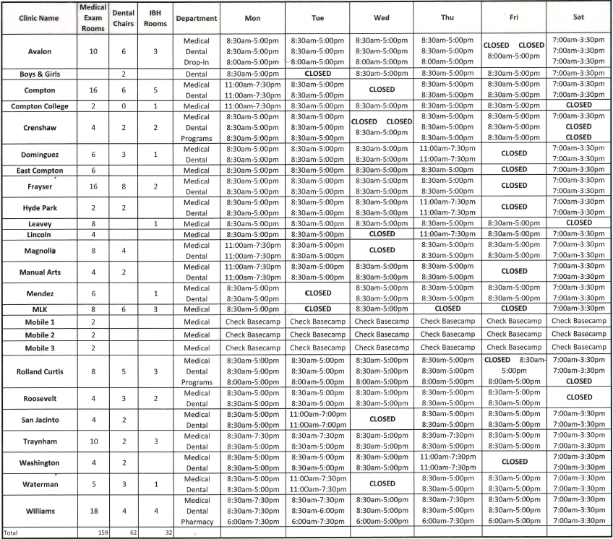

- Additional to the listed rooms, all locations have a lobby, breakroom, and a minimum of 2 restrooms.

PG 4 of 4

